Derivation

Hwang Chan IL

c.hwang

5415279

1. AABB construction

AABB(Axis Aligned Bounding Box Construction)

1. Find xmin, xmax, ymin, ymax  -> Amin(xmin, ymin), Amax(xmax, ymax)
2. Then Center of AABB is $(\frac{x_{min}+ x_{max}}{2}, \frac{y_{min}+ y_{max}}{2})$,

Half extents hx = hy =

1. BC construction

Def : The circle boundary defined as all points P whose distance from center C is equal to radius r

( (C – P)2 = r2 )

1. Find AABB
2. Compute BC that encloses AABB

Center of BC = Center of AABB $(\frac{x_{min}+ x_{max}}{2}, \frac{y_{min}+ y_{max}}{2})$

Radius of BC = $\frac{A_{max}- A_{min}}{2}$ (Amax, Amin is from AABB)

1. Point vs AABB intersection test

Assume that point P(x,y), and AABB(Amin(xmin, ymin), Amax(xmax, ymax))

If P is inside AABB, it satisfies

A. x >= xmin

B. x <= xmax

C. y >= ymin

D. y <= ymax

1. Point vs BC intersection test

Assume that point P (x, y), and BC(C(center), r(radius))

If P is inside BC, it satisfies

1. (C – P)2 > r2

If P is outside BC, it satisfies

1. (C – P)2 < r2

If P is on BC, it satisfies

1. (C – P)2 = r2
2. Point vs convex polygon intersection test

Assume that point P (x, y), and convex Polygon L(counter-clockwise ordered, and has several edges)

If P is inside all edges on Polygon L, they are intersected ( derivation in 5-1)

* 1. Determine the point is inside the line segment

Assume that Polygon L has the counter-clockwise ordered edge from A (Ax, Ay), B (Bx, By) and the Point P (x, y)

Then if (A – P) X (B – P) · (0,0,1) > 0 then the P is inside edge, or P is outside.

* (A – P) X (B – P) · (0,0,1) means the normal vector of AB plane on P, so if it is positive, it is in inside, and if it is negative, it is in outside.

1. BC vs BC intersection test

Assume that BC1(C1, r1), BC2(C2, r2)

1. Let BC3 has radius of r1+r2
2. Then it’s same as intersection test between the BC3(C1, r1+r2) and the point(C2).
3. If C2 is inside BC3, it satisfies

(C1 – C2)2 > (r1+r2)2

If C2 is outside BC3, it satisfies

(C1 – C2)2 < (r1+r2)2

If C2 is on BC3, it satisfies

(C1 – C2)2 = (r1+r2)2

6-1. Closest point on line segment to point.

Assume that the point R, and line segment PQ

1. Case 1 : Closest Point is P

If P satisfies (R – P) · ( Q – P ) < 0, the closest point is P

* (R – P) · ( Q – P ) = | R – P | · | Q – P | · cos **θ** < 0 means cos **θ** is negative and it means -90 < **θ** < 90

1. Case 2 : Closest Point is Q

If P satisfies (R – P) · ( Q – P) > (Q – P) · (Q – P), the closest point is Q

* (R – P) · ( Q – P ) > (Q – P) · (Q – P) means the length between R’s projection on PQ and P is longer than PQ and if it is longer than PQ, it means the distance between P and R’s projection is longer than PQ.

1. Case 3 : Closest Point S is on line segment(not P, Q)

If P satisfies 0 <= (R – P) · (Q – P) <= (Q – P) · (Q – P), the closest point is S

* 0 <= (R – P) · (Q – P) <= (Q – P) · (Q – P) means the length between R’s projection on PQ and P is shorter than PQ and if it is shorter than PQ and much than 0, it means the R’s projection is on PQ.

( S satisfies

S = P + t (Q – P) ( 0 <= t <= 1 )

t = $\frac{\left(R-P \right)·(Q-P)}{{(Q-P )}^{2}}$

)

6-2. Shortest Distance of Point from Line Segment

1. Case 1 : the closest point is P

The shortest distance is (R – P)2

1. Case 2 : the closest point is Q

The shortest distance is (R – Q)2

1. Case 3 : the closest point is S

The shortest distance is (R – P)2 -

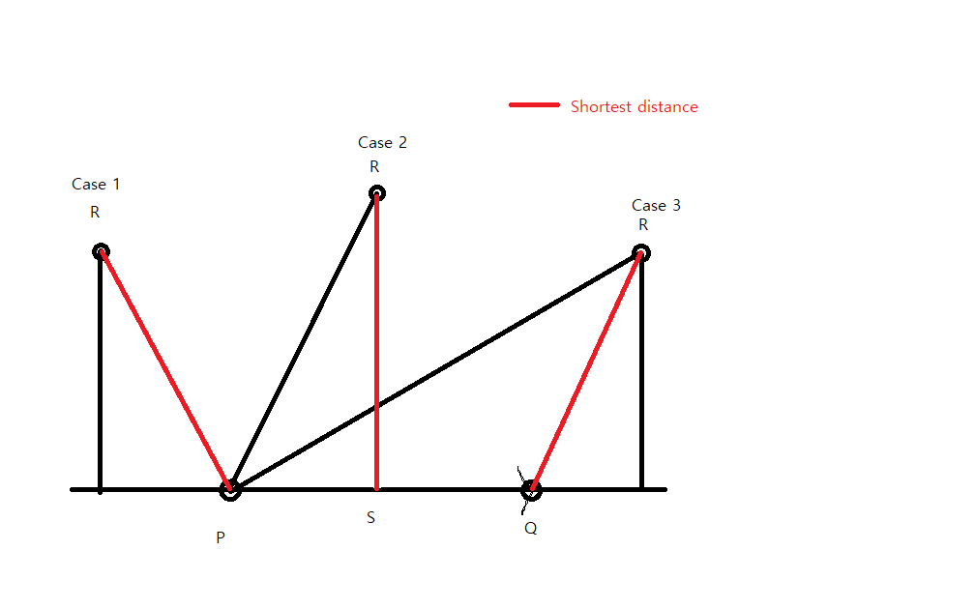

1. BC vs AABB intersection test

Assume that BC(C, r), AABB(Amin(xmin, ymin), Amax(xmax, ymax))

1. At first, if the BC center is inside the AABB , AABB and BC are intersected.

* it’s the intersection test between point C and AABB

1. If BC center is not inside AABB, then determine which section (of AABB) the BC center is in.
2. Then you can find shortest distance between BC center and AABB boundary. If this distance is less than or equal to circle radius, BC and AABB are intersected.
3. BC vs convex polygon intersection test

Assume that BC (C, r), and convex Polygon L (counter-clockwise ordered, and has several edges)

1. At first, if the BC is not intersected with Polygon L’s BC, then Polygon L and BC are not intersected.

* It’s the intersection test between BC and BC

1. Second, if the BC is not intersected with Polygon L’s AABB, then Polygon L and BC are not intersected.

* It’s the intersection test between BC and AABB

1. Third, if the BC center is inside Polygon L, then Polygon L and BC are intersected.

* It’s the intersection test between Point C and Polygon L.

1. If BC center is not inside Polygon L, check whether shortest distance between BC center and polygon edge is shorter than BC radius or not. If the BC radius is shorter than the shortest distance, then Polygon L and BC are intersected.
2. Convex polygon vs convex polygon intersection test

(using Separation Axis Theorem)

Assume that convex Polygon L (counter-clockwise ordered, and has several edges) and convex Polygon R (counter-clockwise ordered, and has several edges)

SAT : Compare the interval of the projection of L on the Separation axis and the interval of max and min projection of R’s vertices on the Separation axis( one of normal vectors of Polygon L)

If the intervals are not intersected, we can know that the objects are not intersected.

So we do same thing to all of normal vectors of Polygon L and R and if all normal vectors pass this SAT test, we can say Polygon L and Polygon R is intersected.

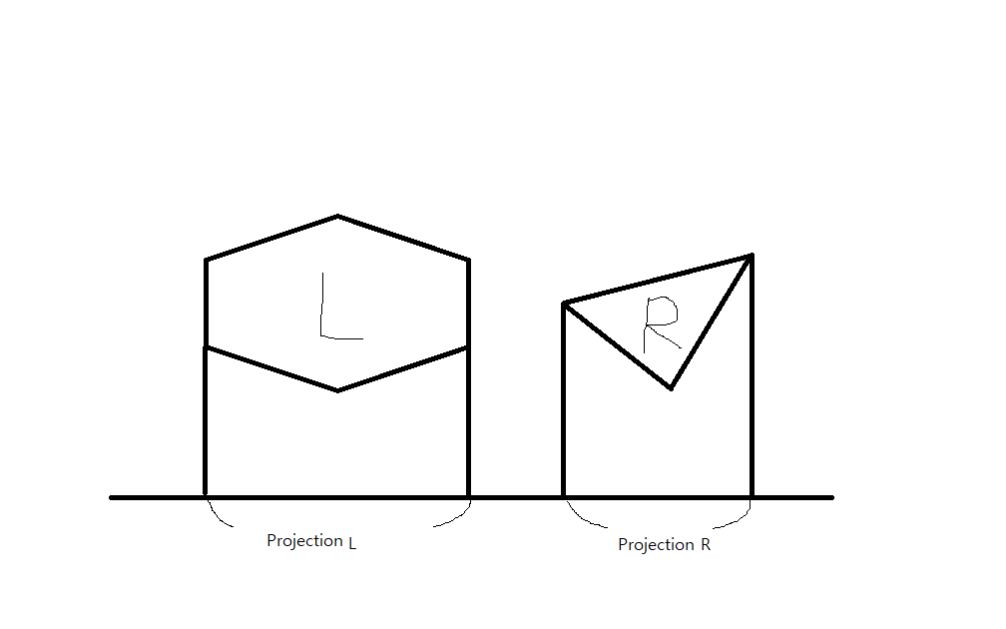

1. Find the projections of L, R onto one of normal vectors of L, R ( it is called Separation Axis )
2. Find the max and min of that projections of L, R.

* L : maxl, minl / R : maxr, minr

1. If maxl < minr or maxr < minl, then it means there is intersection part between intervals.
2. Do A – C to all normal vectors of L, R, and if all intervals has intersection parts, then they are intersected.